D01 – Introduction Responsibility statements

# Identification data

10 A++ <https://github.com/ferruipli/DP1819> | https://trello.com/b/hntd7yAl/d01-acme-shout

Group Level URL of your project and your artefact management systems

Sevilla, 15 Octubre 2018

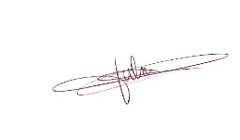Place, date

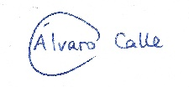

Calle González, Álvaro García Gallego, Julia

Student #1: Surname, name, and signature Student #2: Surname, name, and signature

Jiménez Vega, María Nolé Anguita, Antonio

Student #3: Surname, name, and signature Student #4: Surname, name, and signature

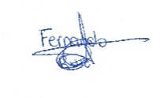

Ruiz Pliego, Fernando Manuel

Student #5: Surname, name, and signature

# Responsibility statements

Student #6: Surname, name, and signature

[✓ ] I am an author of this deliverable. I have not cheated in any way.

[✓ ] I have collaborated with my partners on producing this deliverable; in other words, neither have I ridden their coattails nor gobbled them up.

[✓ ] I have learnt from working on this deliverable, so that I can pass my control checks.

[✓ ] I have organised this deliverable according to the guidelines that are available in document “On your deliverables.pdf”, which is available at the USE’s e-learning platform.

[✓ ] I understand that my deliverable will be considered failed if I fail to meet any of its require- ments, if I fail to submit it by the deadline, or if I do not deliver a filled copy of this form.

[✓ ] I understand that failing this deliverable might amount to failing the subject.

[✓] I understand that I must have a contingency plan and that submitting my deliverable very close to the deadline is likely to result in disaster.